Quick Reference Guide for accessing and adding CITI Program Webinars

1. Once logged into your CITI profile, go to the top of the page and select My Courses



1. Next, click View Courses

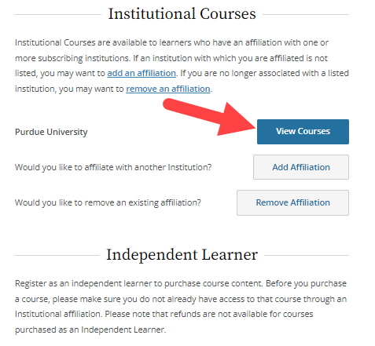

1. This screen will show your Active, Ready to Begin and Completed CITI Courses. Scroll down to the box labeled Learner Tools for Purdue University and select Add a Course.

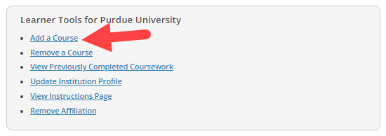

1. Groups of ***Questions*** will appear in a list beginning with Question 1, ***Scroll to Question 11*** for the list of available Webinars. The Webinars may appear in alphabetical order, just select the one(s) that you would like to add to your Courses. You can add them one at a time or add several you plan to review at a later date. You may repeat this action to Add or Remove Courses or Webinars at any time. Once you have selected the Webinar(s) you are interested in and wish to have them added to your Courses be sure the box(s) have been marked with a check.



1. Once your selection is complete, click the Submit button at the bottom of the list to add them to your Courses.



1. Before beginning a Webinar, you will be asked to Agree to the Terms of Service & Privacy and Cookie Policy for access to the CITI Program materials. You will not be permitted access to a Webinar before completing this final step.

